1. **Browser and Basic Commands**

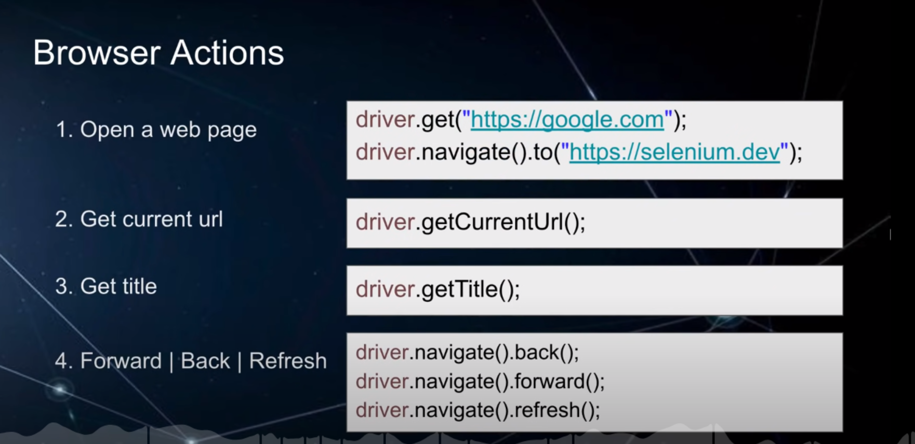

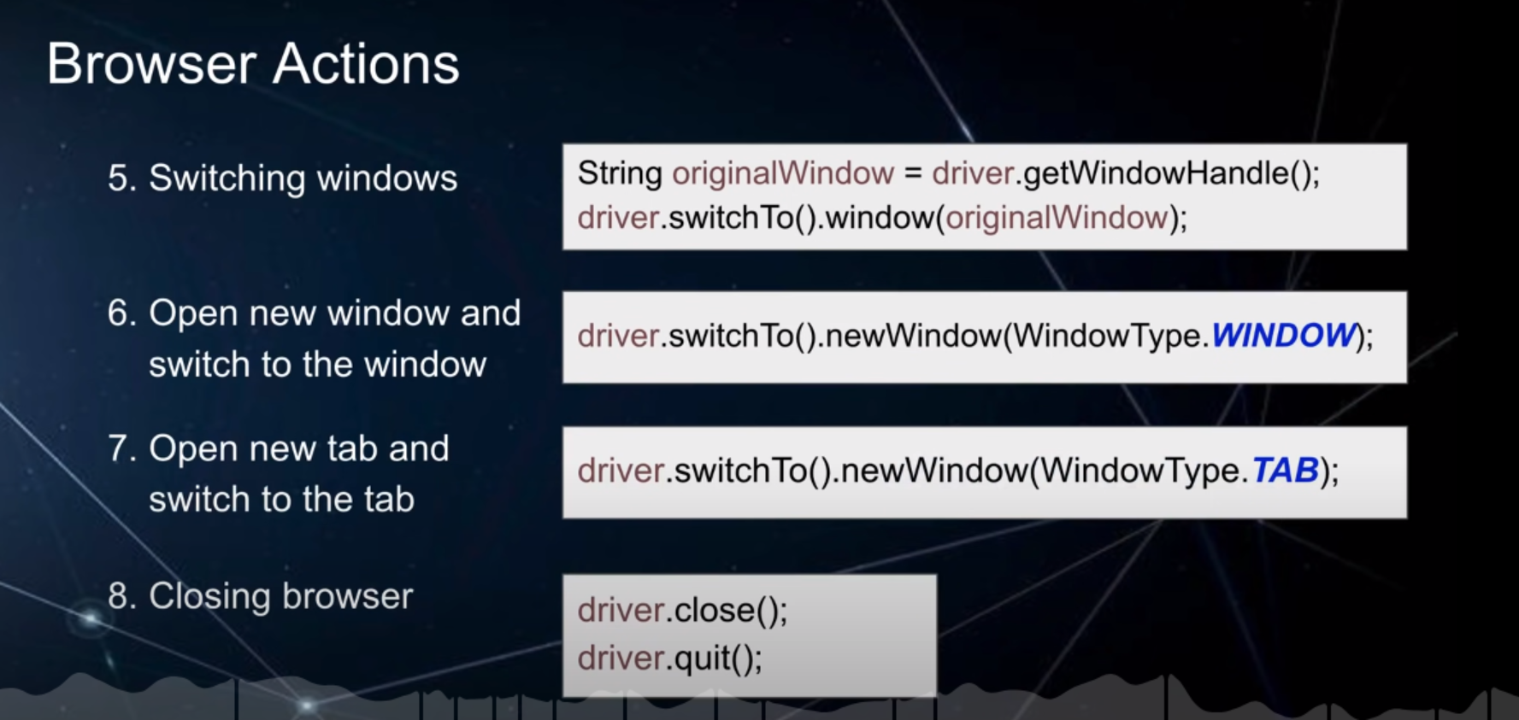

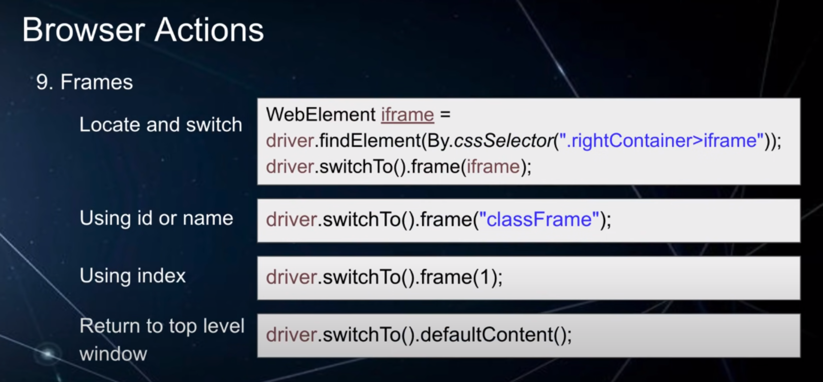

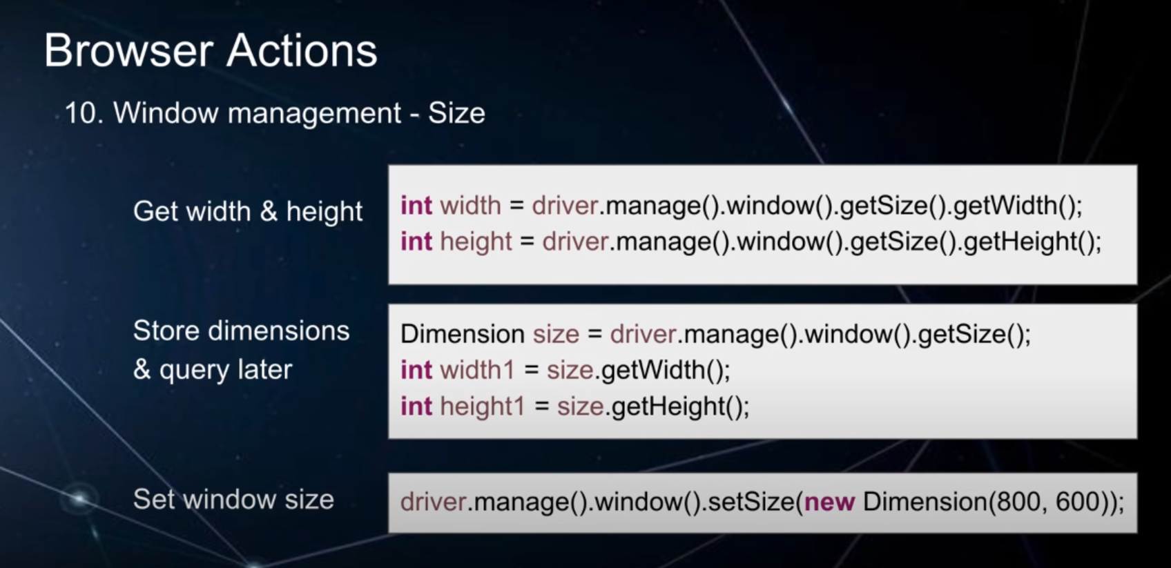

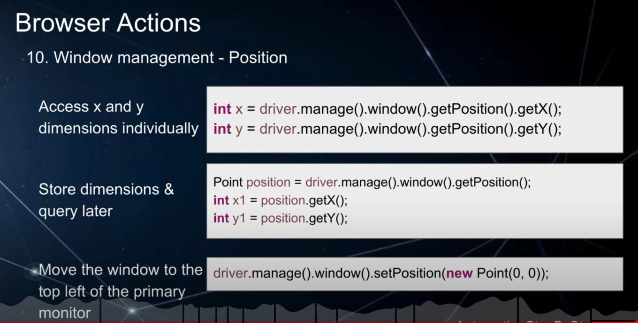

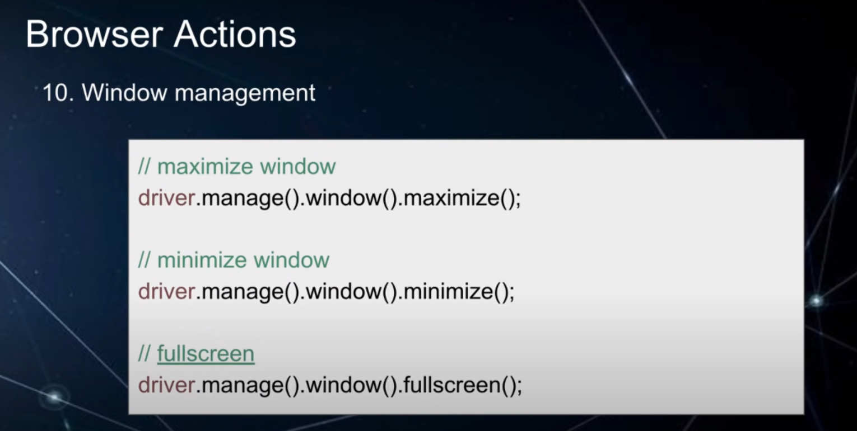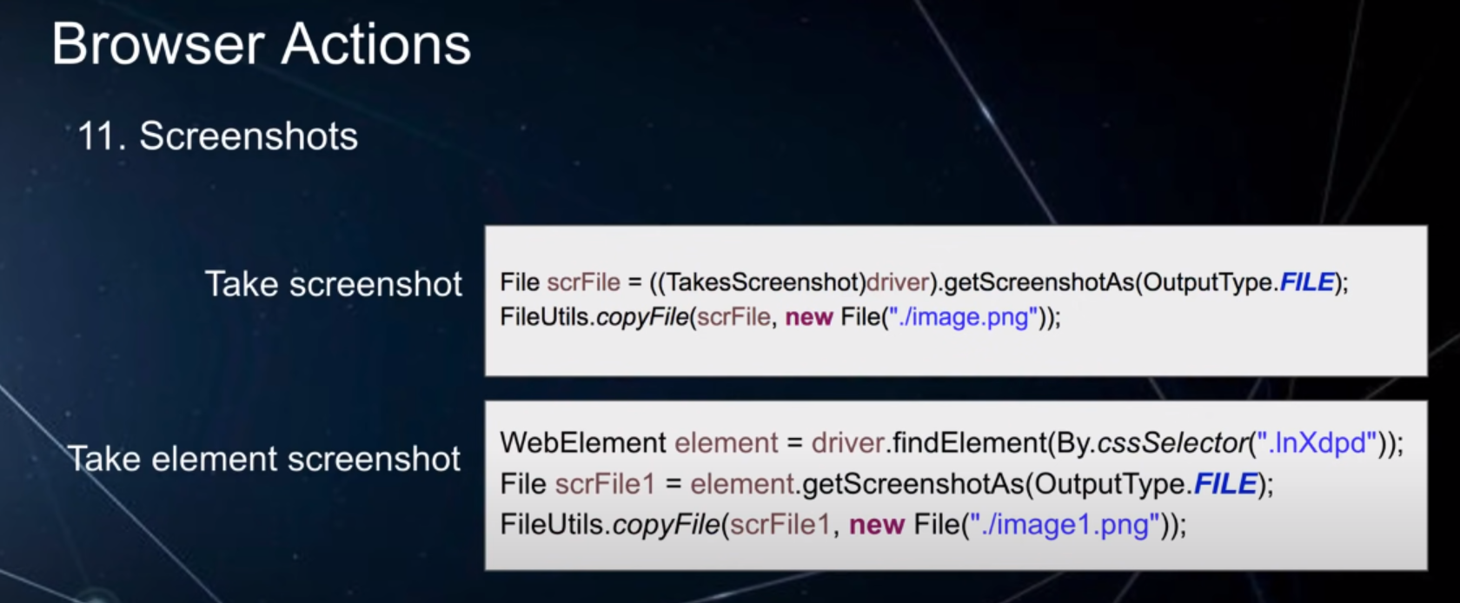

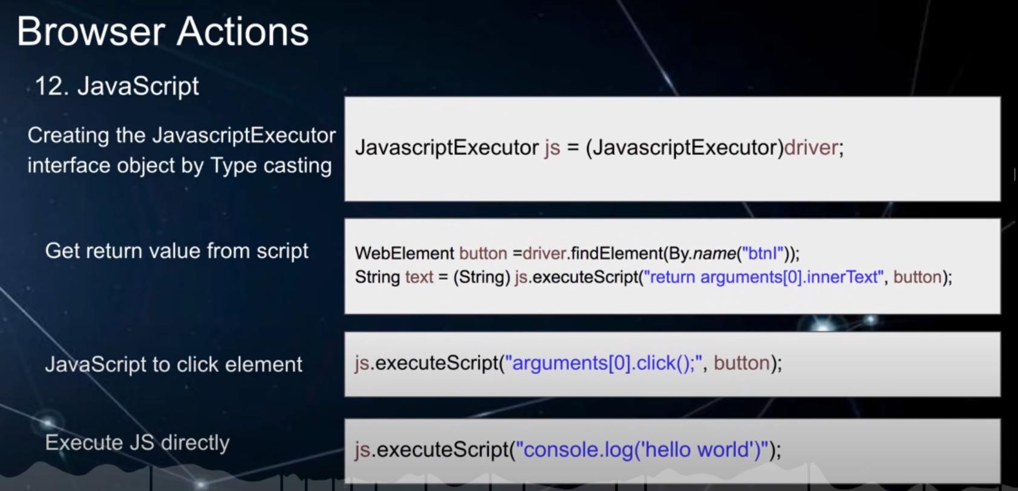

1. **WebElements and Locators**

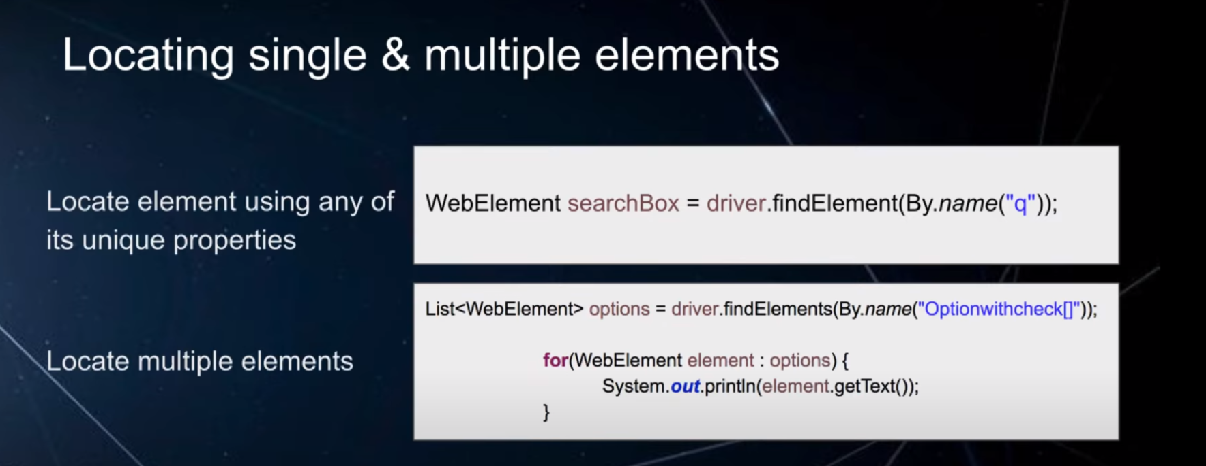

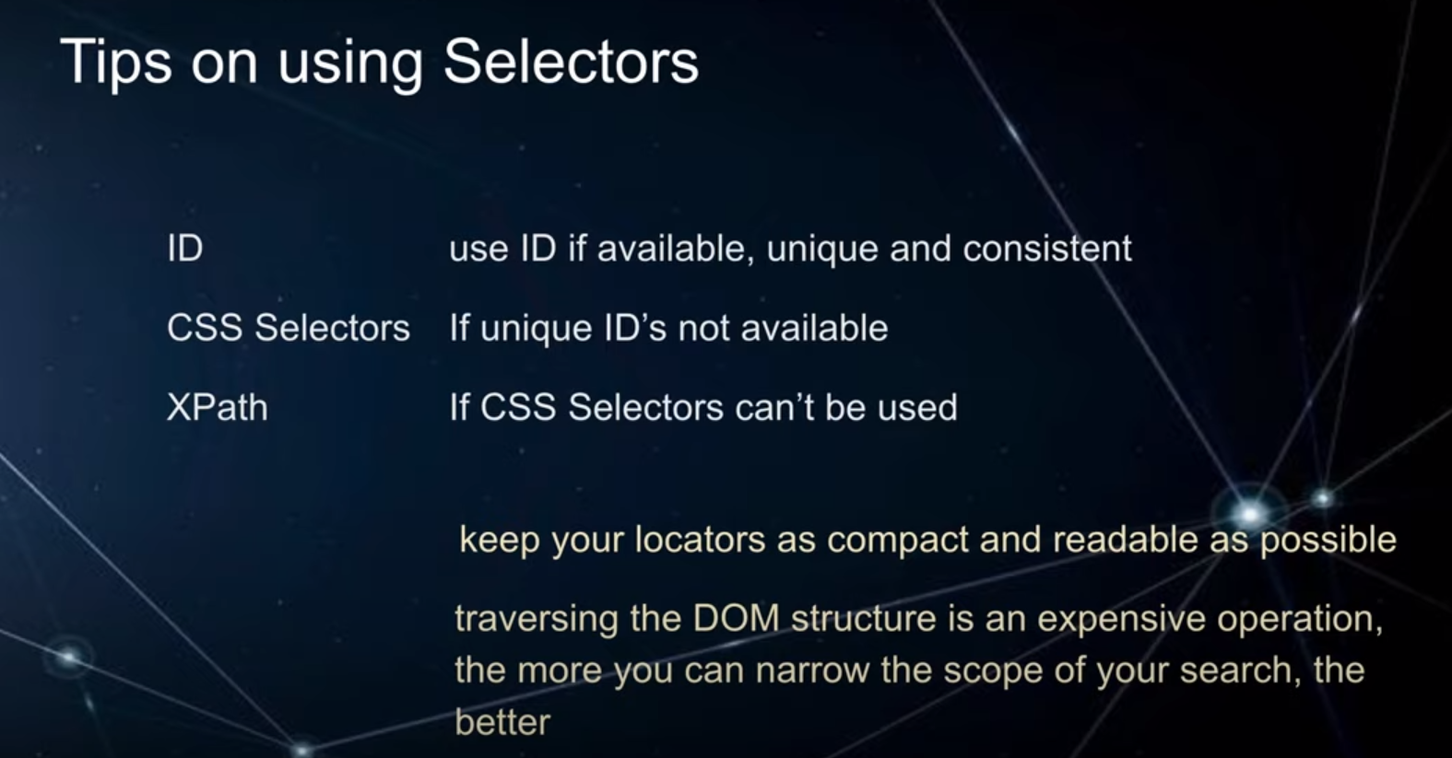

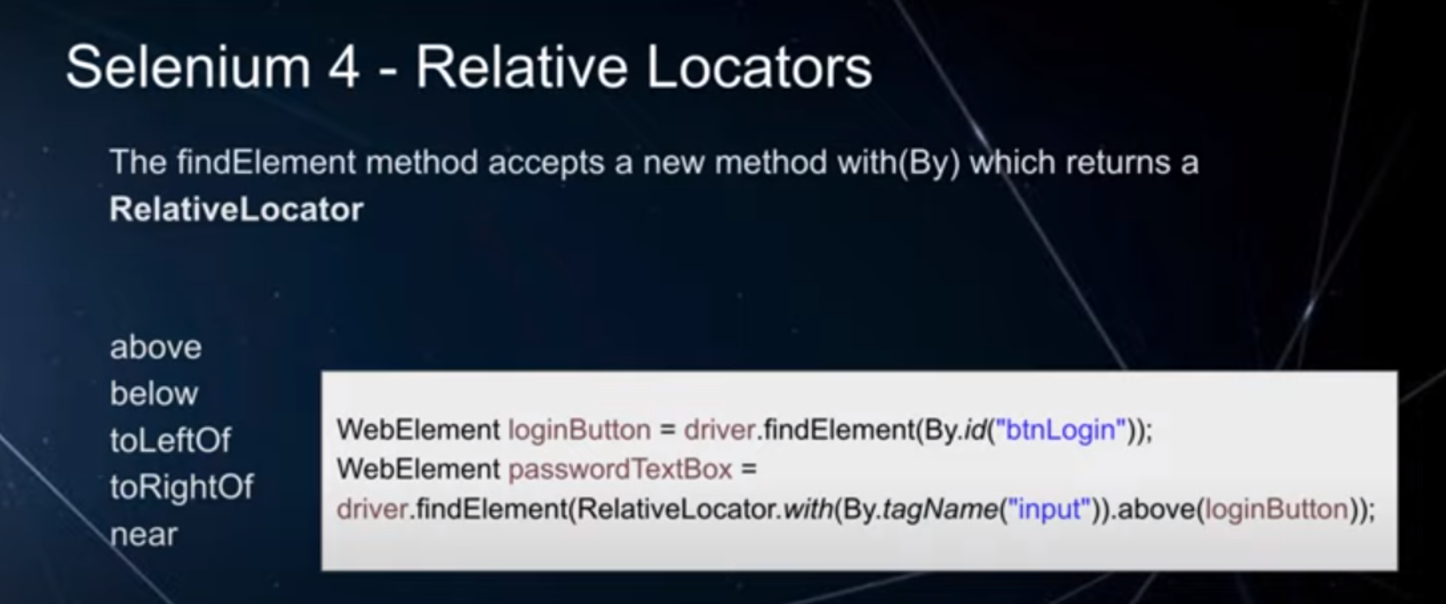

**Locators:**

In Selenium WebDriver we have to do 2 things:

1. Identify Locators
2. Perform action on locators

Apart from it the other tools like Maven, Cucumber, Jenkins, TestNg, Log4J, … are used to support or make these 2 things easy to use framework, maintainable, reusable , scalable, …

Selenium Locators -

1. Id
2. Name
3. Link Text
4. Partial LinkText
5. ClassName
6. Tag Name
7. CSS Selector
8. XPath

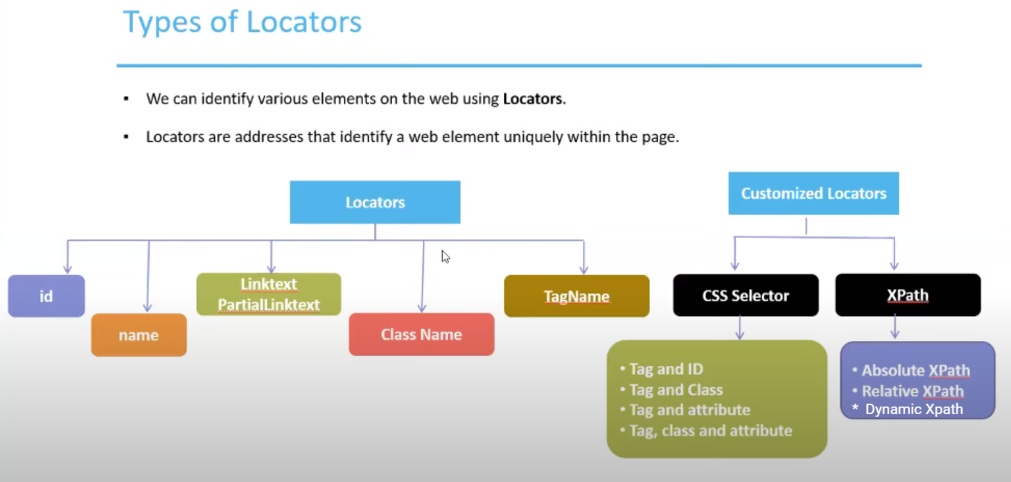

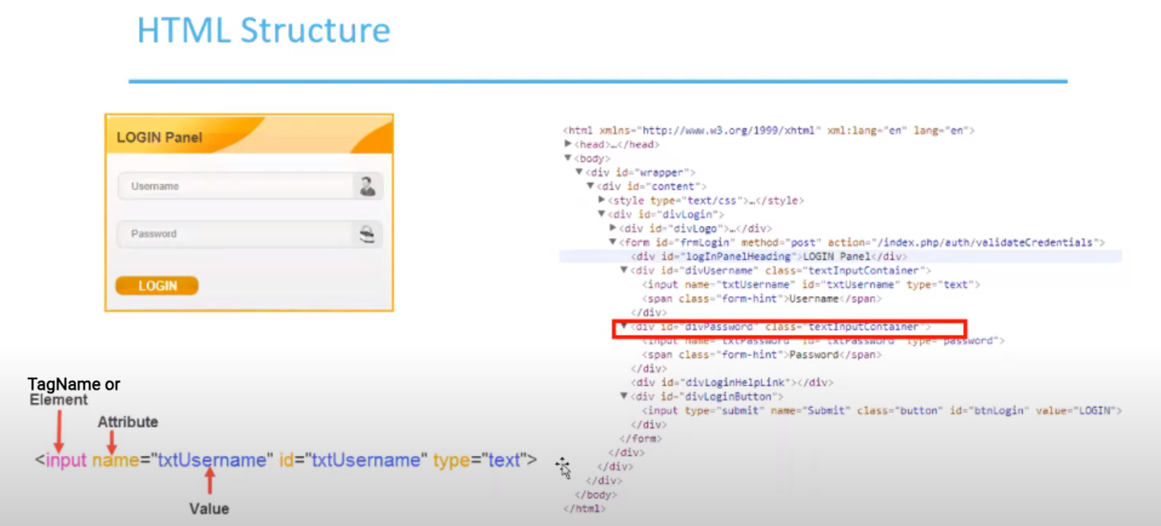

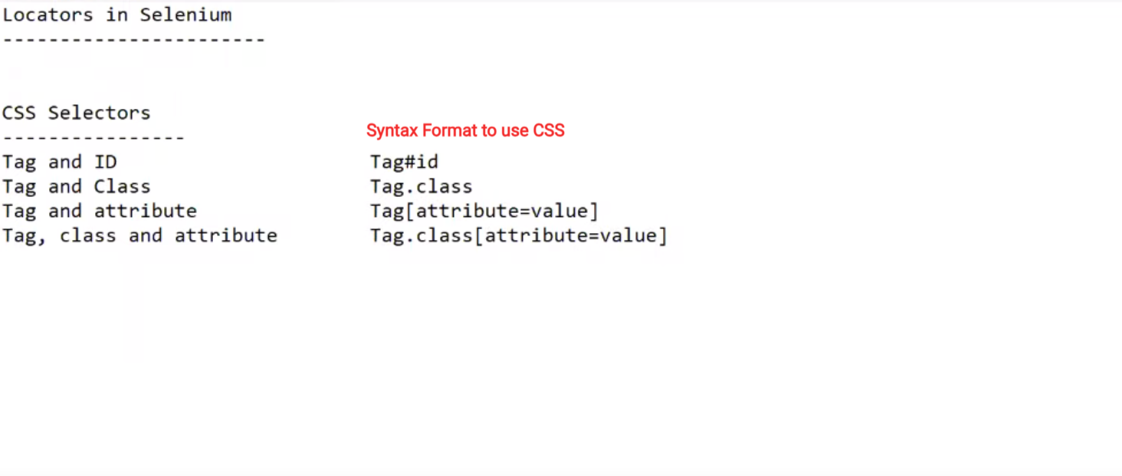

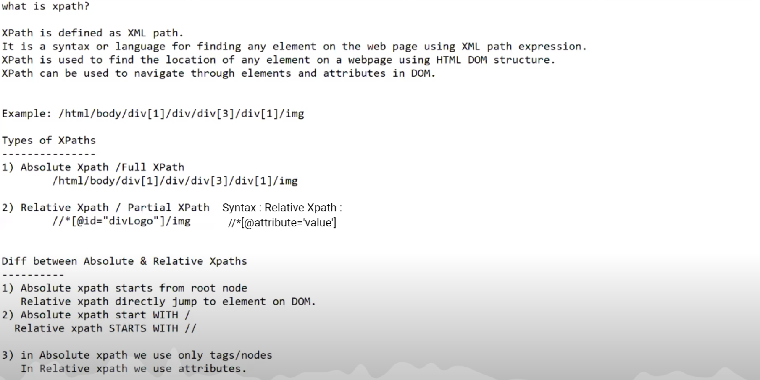

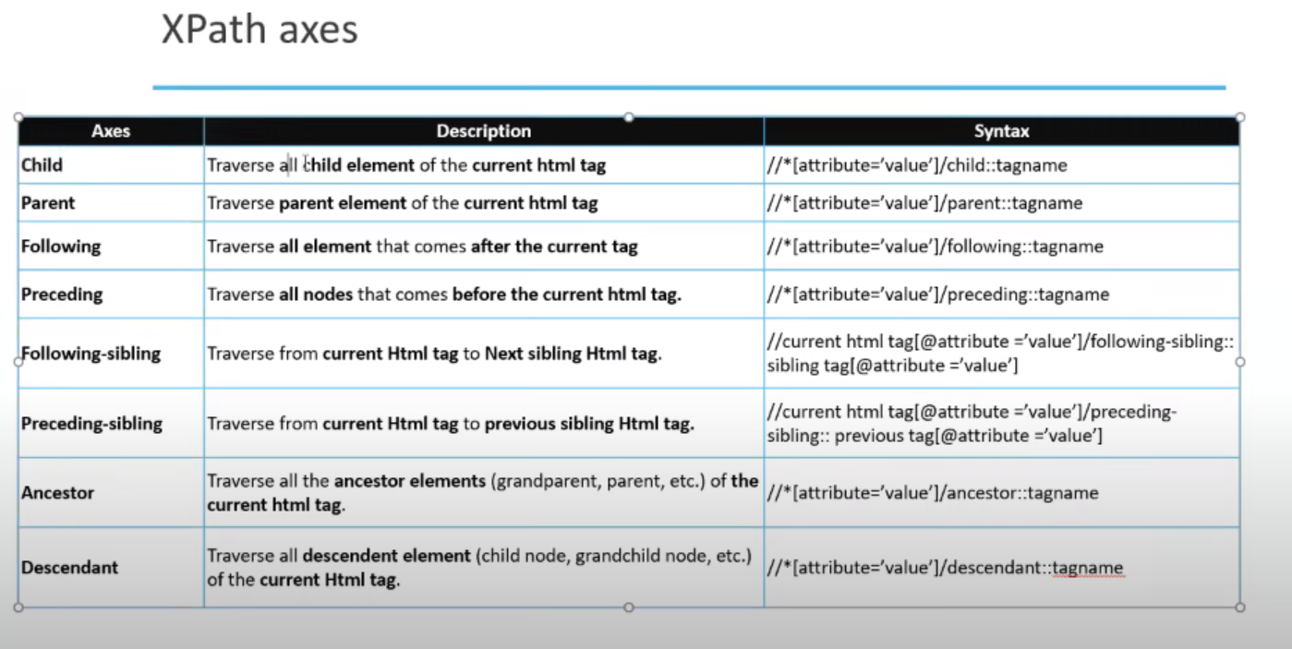

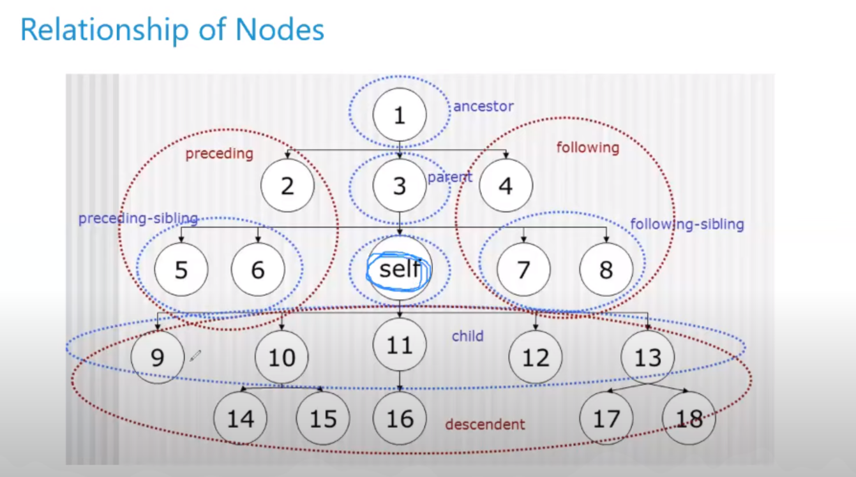

XPath axes are a way to navigate through the elements of an XML or HTML document. In the context of Selenium with Java, XPath axes are often used to locate specific elements on a web page. To understand XPath axes in layman's terms, think of them as directions or paths that help you pinpoint elements relative to other elements. There are several XPath axes you can use:

1. **Child (/) Axis**: This axis allows you to select immediate child elements of a parent element. For example, if you have an HTML structure with a list of items inside an unordered list (**<ul>**), you can use **/** to navigate to the list items (**<li>**) directly under the **<ul>**.

javaCopy code

WebElement listItem = driver.findElement(By.xpath("//ul[@id='myList']/li"));

1. **Descendant (//) Axis**: The **//** axis allows you to select elements anywhere within the document, not just immediate children. For example, you can use **//** to find all **<a>** links on a page, regardless of where they are nested.

javaCopy code

List<WebElement> allLinks = driver.findElements(By.xpath("//a"));

1. **Parent (..) Axis**: This axis lets you select the parent element of the current element. For instance, if you have located an element inside a table cell (**<td>**), you can use **..** to access the **<td>** element itself.

javaCopy code

WebElement tableCell = driver.findElement(By.xpath("//td[contains(text(),'Some Text')]")); WebElement tableRow = tableCell.findElement(By.xpath(".."));

1. **Following (following::) Axis**: The **following::** axis selects elements that come after the current element in the document. For example, you can use it to find the **<input>** element that follows a specific **<label>**.

javaCopy code

WebElement label = driver.findElement(By.xpath("//label[contains(text(),'Username')]")); WebElement input = label.findElement(By.xpath("following::input"));

1. **Preceding (preceding::) Axis**: The **preceding::** axis selects elements that come before the current element in the document. This can be useful for finding elements that precede a specific element.

javaCopy code

WebElement currentElement = driver.findElement(By.xpath("//div[@id='currentElement']")); WebElement precedingElement = currentElement.findElement(By.xpath("preceding::p"));

1. **Following-Sibling (following-sibling::) Axis**: This axis selects elements that are siblings of the current element and come after it. For example, you can use it to locate the next **<div>** element on the same level as the current one.

javaCopy code

WebElement currentDiv = driver.findElement(By.xpath("//div[@id='currentDiv']")); WebElement nextDiv = currentDiv.findElement(By.xpath("following-sibling::div"));

1. **Preceding-Sibling (preceding-sibling::) Axis**: This axis selects elements that are siblings of the current element and come before it. It can be used to locate the previous elements on the same level.

javaCopy code

WebElement currentDiv = driver.findElement(By.xpath("//div[@id='currentDiv']")); WebElement previousDiv = currentDiv.findElement(By.xpath("preceding-sibling::div"));

XPath axes help you navigate the structure of a web page effectively, allowing you to locate elements based on their relationships with other elements. When using Selenium with Java, you can combine these axes with various element locators to find and interact with elements on a webpage.

**Shadow Xpath:**

In Selenium, XPath is a powerful and flexible language used to locate elements on a web page so that you can interact with them (e.g., click a button, fill out a form, or extract information). "Shadow XPath" is a term that specifically relates to dealing with elements inside shadow DOMs, which are isolated DOM trees within a web page. Shadow DOMs are often used in web components to encapsulate styles and behavior, making it challenging to locate elements within them using traditional XPath.

To explain "Shadow XPath" in layman's terms, imagine a web page as a big house with multiple rooms. Each room represents a shadow DOM, which is like a separate mini-house inside the main house. You want to find and interact with objects (HTML elements) inside these rooms, but the doors to these rooms are locked, making it harder to access them directly.

In Selenium, you can use "Shadow XPath" to find elements inside these locked rooms (shadow DOMs) by providing a special XPath expression that navigates through the main house, unlocks the doors to the rooms, and then selects the objects you need.

Here's a simple example in Java using Selenium to demonstrate "Shadow XPath":

In this example, we:

import org.openqa.selenium.By;

import org.openqa.selenium.JavascriptExecutor;

import org.openqa.selenium.WebDriver;

import org.openqa.selenium.WebElement;

import org.openqa.selenium.chrome.ChromeDriver;

public class ShadowXPathExample {

public static void main(String[] args) {

// Set up Selenium WebDriver (Make sure you have ChromeDriver installed)

System.setProperty("webdriver.chrome.driver", "path/to/chromedriver.exe");

WebDriver driver = new ChromeDriver();

// Open a webpage with shadow DOM elements

driver.get("https://example.com");

// Find the main element that contains the shadow DOM

WebElement shadowHost = driver.findElement(By.id("shadow-host"));

// Execute JavaScript to access the shadow DOM

JavascriptExecutor jsExecutor = (JavascriptExecutor) driver;

WebElement shadowElement = (WebElement) jsExecutor.executeScript(

"return arguments[0].shadowRoot.querySelector('your-shadow-xpath-expression');", shadowHost

);

// Now you can interact with the element inside the shadow DOM

shadowElement.click();

// Close the WebDriver

driver.quit();

}

}

1. Open a web page containing a shadow DOM element (represented by an element with an ID of "shadow-host").
2. Use JavaScript to access the shadow DOM using a "Shadow XPath" expression inside the **executeScript** method.
3. Once we have the element within the shadow DOM, we can interact with it as needed.

Please replace **"your-shadow-xpath-expression"** with the actual XPath expression you need to locate the element inside the shadow DOM.

Remember that working with shadow DOMs and "Shadow XPath" may vary depending on the specific web page and its structure, so you'll need to inspect the page source and use appropriate XPath expressions accordingly.

1. **Waits:**

Think of Selenium WebDriver as a tool that helps you automate tasks on a website, like filling out forms or clicking buttons. Sometimes, when you're interacting with a website, certain elements (like buttons, text boxes, or images) may not load instantly. They might take a bit of time to appear or change on the page.

Now, imagine you're trying to click a "Submit" button on a webpage, but the button hasn't fully loaded yet. If you tell Selenium to click the button immediately, it won't work because the button isn't ready.

This is where Selenium's Wait feature comes in. It's like telling Selenium to be patient and wait for the button to become clickable before trying to click it. You're basically saying, "Hey, Selenium, don't rush. Wait for the button to show up, and once it's ready, go ahead and click it."

So, Selenium's Wait is a way to make your automated actions more reliable by allowing Selenium to wait for elements to appear or change on the webpage before it interacts with them. It ensures that your automation doesn't run into problems due to the webpage not being ready yet.

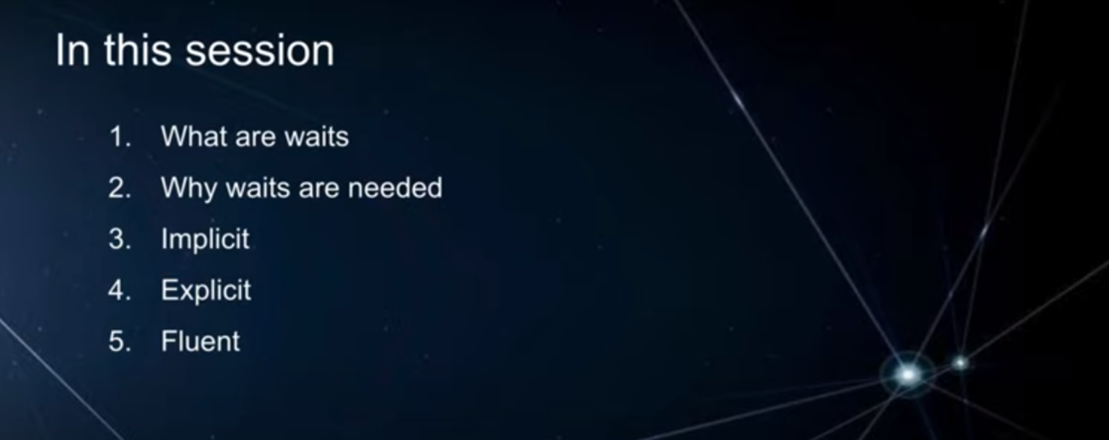

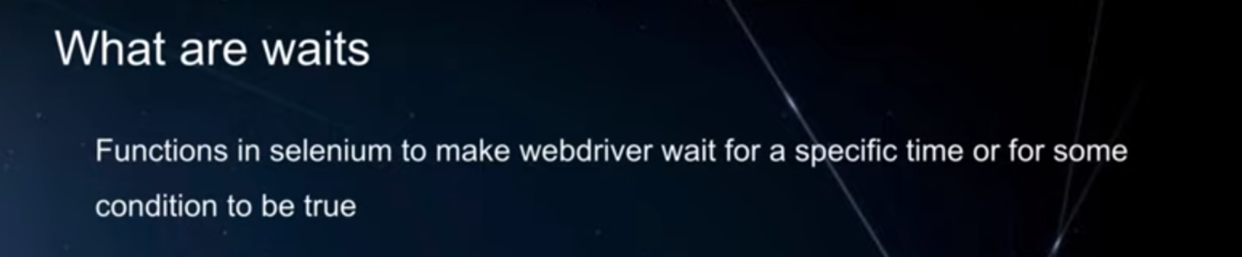

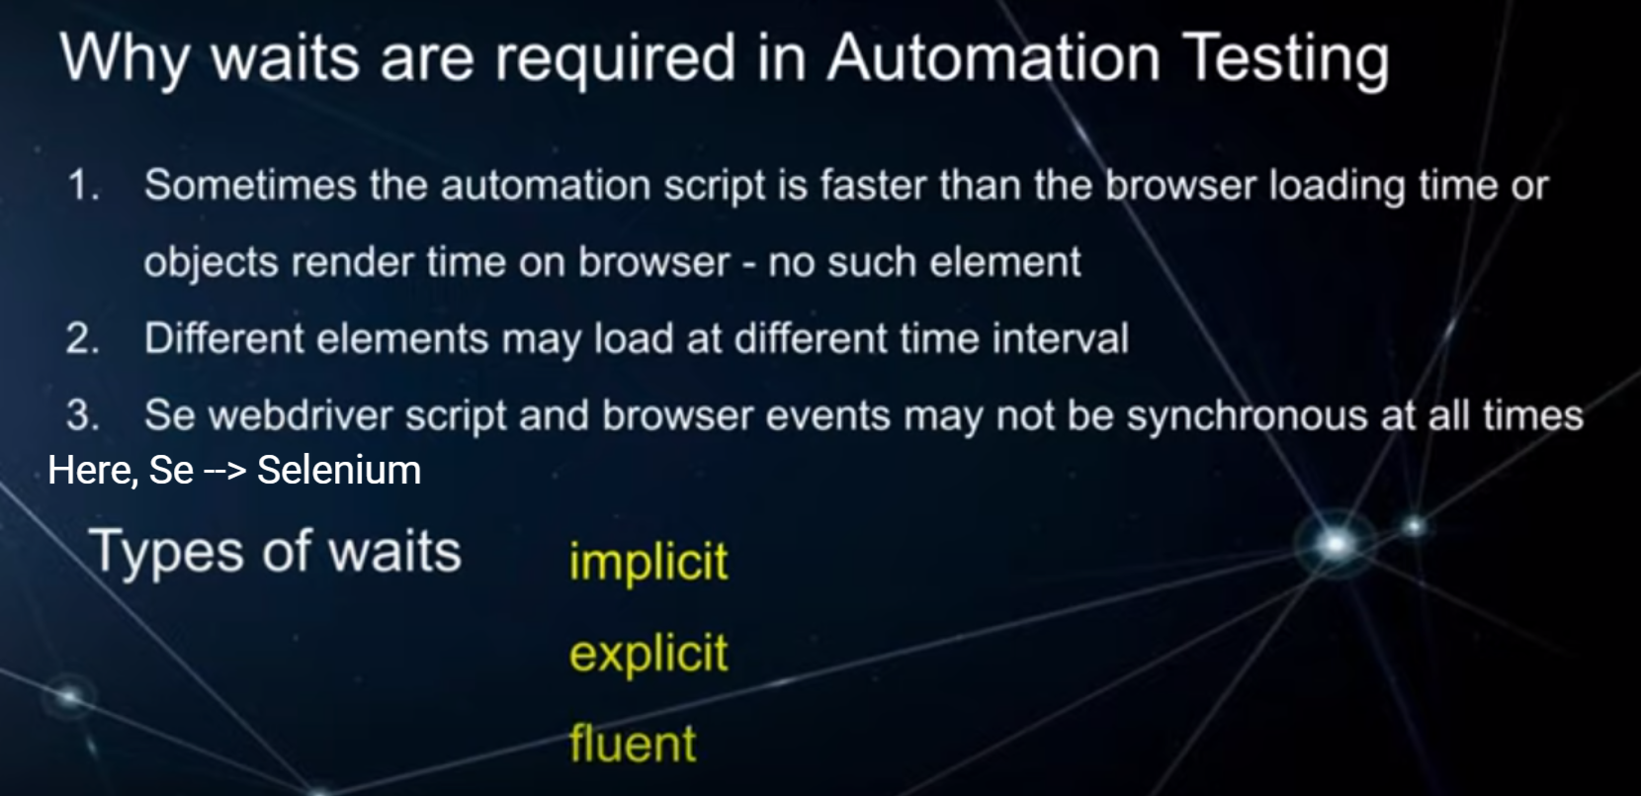

* 1. **Implicit Wait:**
     1. **Implicit Wait : Explanation - 1**

Imagine you're using Selenium to automate tasks on a website, like filling out a form or clicking buttons. Sometimes, webpages take a variable amount of time to load different elements (like buttons, text boxes, or images). If you tell Selenium to interact with these elements without any waiting, it might run into issues because the elements might not be ready on the page yet.

An implicit wait is like giving Selenium a general instruction to wait for a certain amount of time before it tries to find or interact with any element on a webpage. It's like saying, "Hey, Selenium, be patient and wait for a little while before you do anything. If you can't find an element immediately, wait for a bit, and then try again."

Here's how an implicit wait works:

1. You set a global or default waiting time when you initialize your Selenium WebDriver. For example, you can tell Selenium to wait for 10 seconds.
2. Whenever you use a command to find or interact with an element (e.g., clicking a button or typing in a text box), Selenium will wait for the specified amount of time (e.g., 10 seconds) before it throws an error if the element is not found or ready.
3. If the element becomes available before the specified wait time is over, Selenium will proceed with the action immediately.
4. In simple terms, an implicit wait adds a safety buffer to your Selenium automation. It helps handle situations where web elements take a little extra time to load without requiring you to specify explicit waits for each individual element. However, it's essential to choose an appropriate wait time to balance between reliability and efficiency, as setting it too high can slow down your automation unnecessarily.
   * 1. **Implicit Wait : Explanation - 2**

An implicit wait in Selenium WebDriver is like telling Selenium to wait for a certain amount of time before attempting to find an element on a webpage. It's a global setting that applies to all elements you want to interact with throughout your entire test script, unless explicitly overridden.

Here's a simple way to understand it:

1. Imagine you're using a GPS navigation system in your car to find a specific location. You set the GPS to give you directions, but you know that sometimes the GPS may take a few moments to calculate the route, especially if you're in an area with poor signal. In this case:
2. You set an implicit wait: This is like telling the GPS, "Okay, before you start giving me directions, wait for, let's say, 30 seconds for a stable GPS signal or for the route to be calculated." This wait time is a fixed amount you specify.
3. You start driving: The GPS doesn't immediately start giving you directions; instead, it waits for the specified time.
4. After the wait time is over: If the GPS has found the route within those 30 seconds, it will start providing you with directions right away. If it still can't find the route after 30 seconds, it will continue to try but won't keep you waiting indefinitely.

In Selenium, an implicit wait works similarly:

* You set an implicit wait time (e.g., 10 seconds) at the beginning of your script.
* When you tell Selenium to find an element on a webpage, it will wait up to the specified time for that element to appear before throwing an error.
* If the element is found within the wait time, Selenium proceeds with the next step in your script.
* If the element is not found within the wait time, Selenium will raise a "NoSuchElementException" or a similar error.
* Implicit waits can be useful to make your Selenium scripts more robust, especially when dealing with elements that might not load immediately. However, it's important to use them judiciously and not set excessively long wait times, as this can make your tests slow.

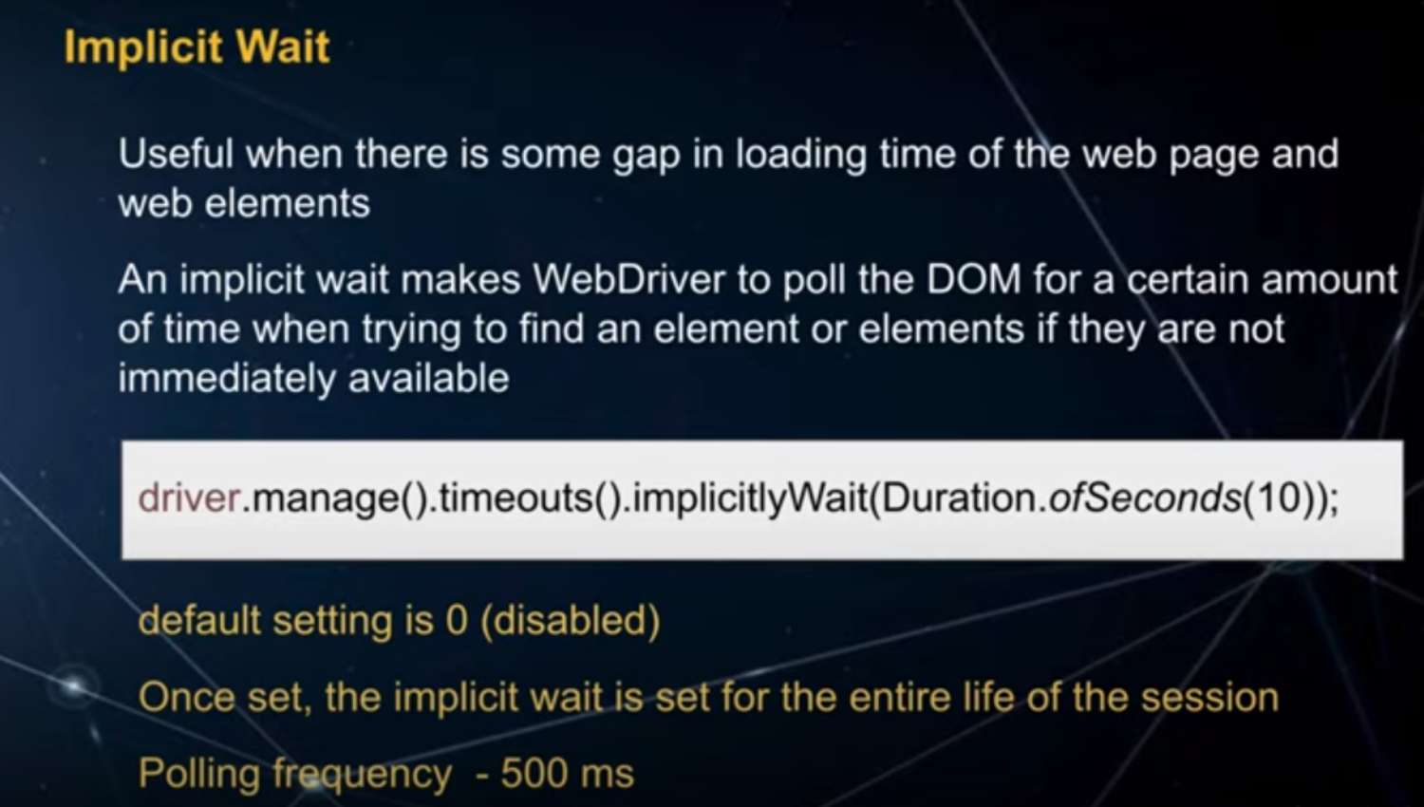

* 1. **Explicit Wait:**

Let's break down Selenium WebDriver's Explicit Wait in simple terms.

Imagine you're trying to catch a bus, and you know the bus is supposed to arrive in 10 minutes. Instead of standing at the bus stop and constantly checking if the bus has arrived every few seconds, you decide to wait for the bus to come in exactly 10 minutes. That's similar to what Explicit Wait does in Selenium WebDriver.

In web automation, you often interact with web pages, and sometimes elements on those pages take some time to load or change. Instead of constantly checking if a specific element (like a button or a text box) is available on the page, you can use Explicit Wait to wait for it to appear or meet certain conditions.

Here's how it works in Selenium WebDriver:

* 1. You tell Selenium to wait for a specific element or condition.
  2. Selenium keeps checking the page at regular intervals (e.g., every 500 milliseconds) until the element appears or the condition is met.
  3. Once the element is found or the condition is satisfied, Selenium continues with the next step in your automation script.
  4. So, it's like telling Selenium, "Hey, don't rush; take your time and make sure this element is there or the condition is met before you proceed with the next action." This helps ensure that your automation script works smoothly even when web pages take a bit of time to load or update.

In summary, Explicit Wait in Selenium WebDriver is like patiently waiting for a bus to arrive at a specific time instead of constantly checking if it's there yet. It's a useful feature to make your web automation scripts more reliable.

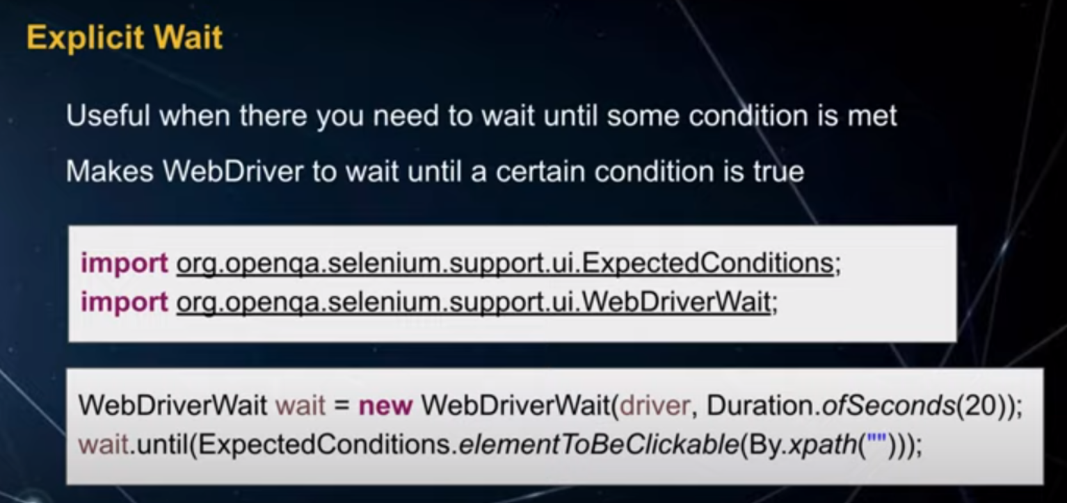

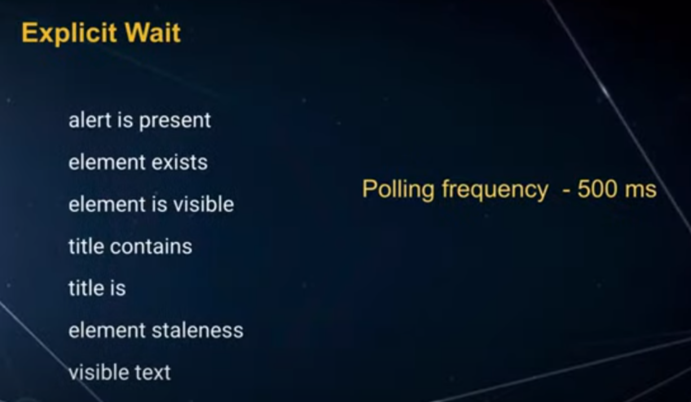

* 1. **Fluent Wait**

Imagine you're waiting for a bus at a bus stop. You know the bus is supposed to arrive in 10 minutes, but you don't want to just stare at your watch the whole time because that would be boring. Instead, you decide to check your watch every minute and see if the bus has arrived. If it hasn't, you wait for another minute and check again.

Selenium WebDriver's fluent wait is kind of like that. When you're writing automation scripts to interact with a web page, you often have to wait for certain elements or conditions to be met before you can proceed with your script. For example, you might need to wait for a button to become clickable, or for a specific message to appear on the page.

Fluent wait helps you do this in a more flexible and efficient way. Instead of just waiting for a fixed amount of time (like waiting exactly 10 seconds), you set up a fluent wait to check for the condition you're waiting for at regular intervals. You specify two things:

1. The maximum amount of time you're willing to wait (like saying you're willing to wait up to 10 minutes for the bus).
2. How often you want to check for the condition (like checking your watch every minute).

With fluent wait, Selenium will repeatedly check for the condition during the specified time period. As soon as the condition is met (just like the bus arriving), your script can continue without wasting any unnecessary time. This makes your automation scripts more efficient because they don't have to wait longer than needed, just like you don't have to wait at the bus stop for the full 10 minutes if the bus arrives earlier.

In summary, Selenium WebDriver's fluent wait is a way to wait for specific conditions to be met on a web page while periodically checking for them, ensuring that your automation scripts can continue as soon as the conditions are satisfied, making your scripts more efficient and responsive.

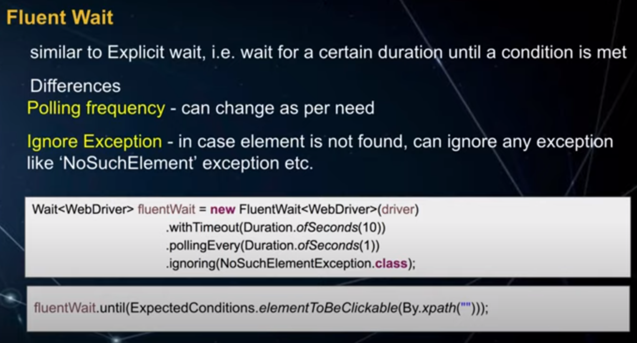

1. **Pop-ups and Alerts**



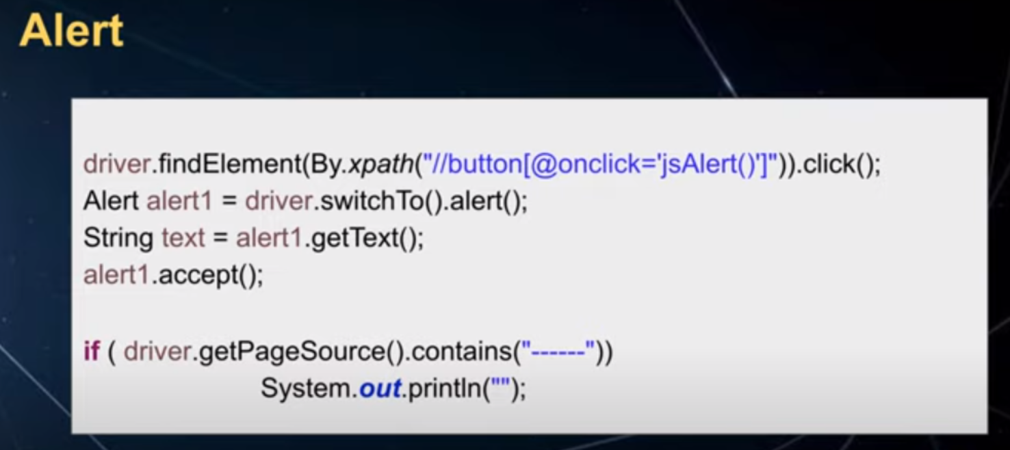

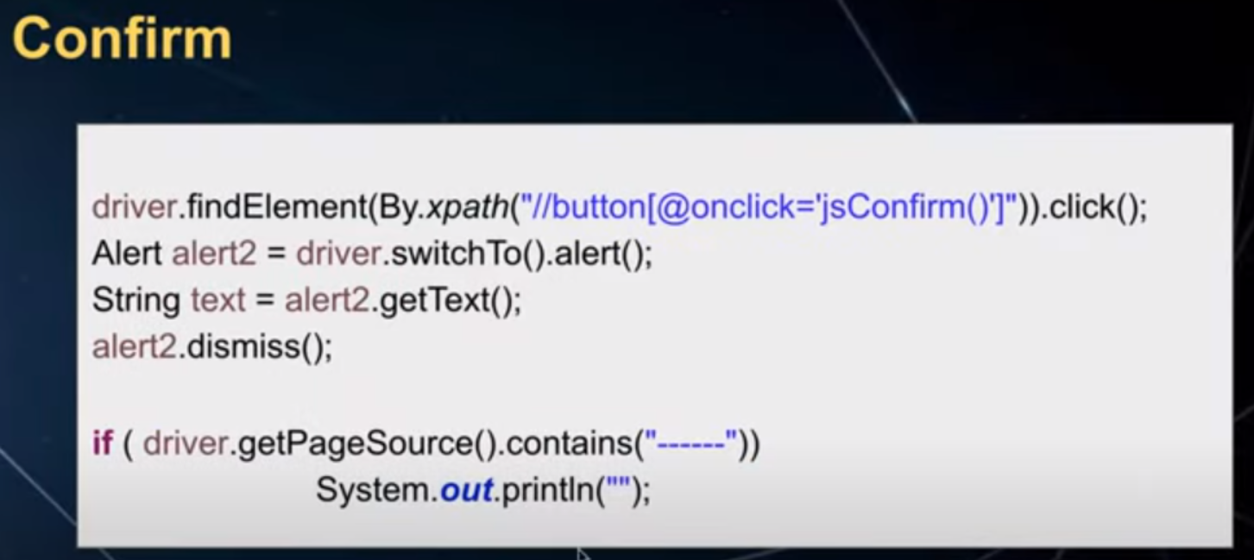

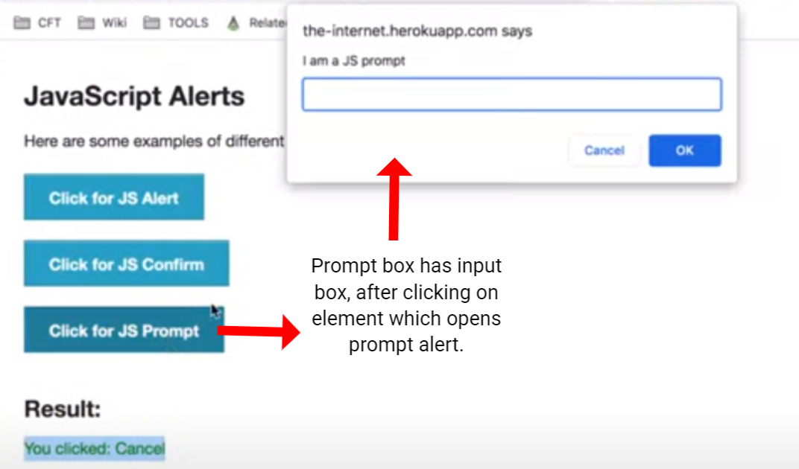

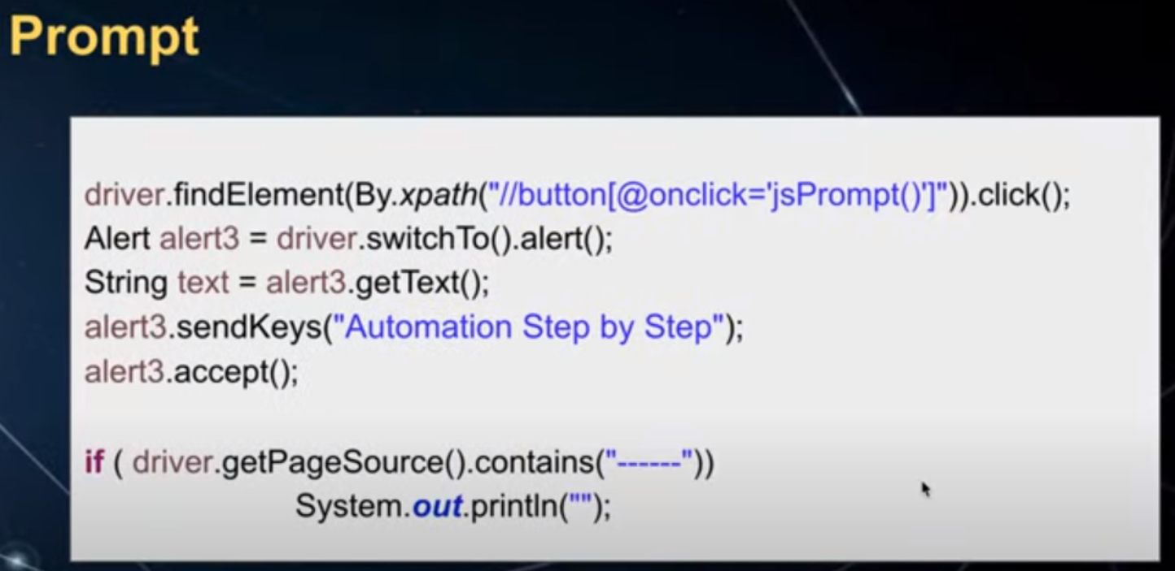

1. **What is Proxy? And How to use Proxy?**

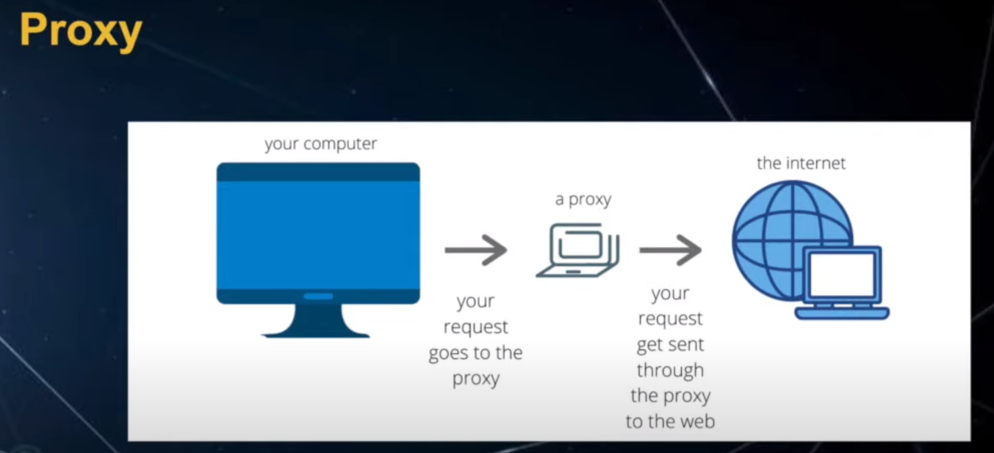

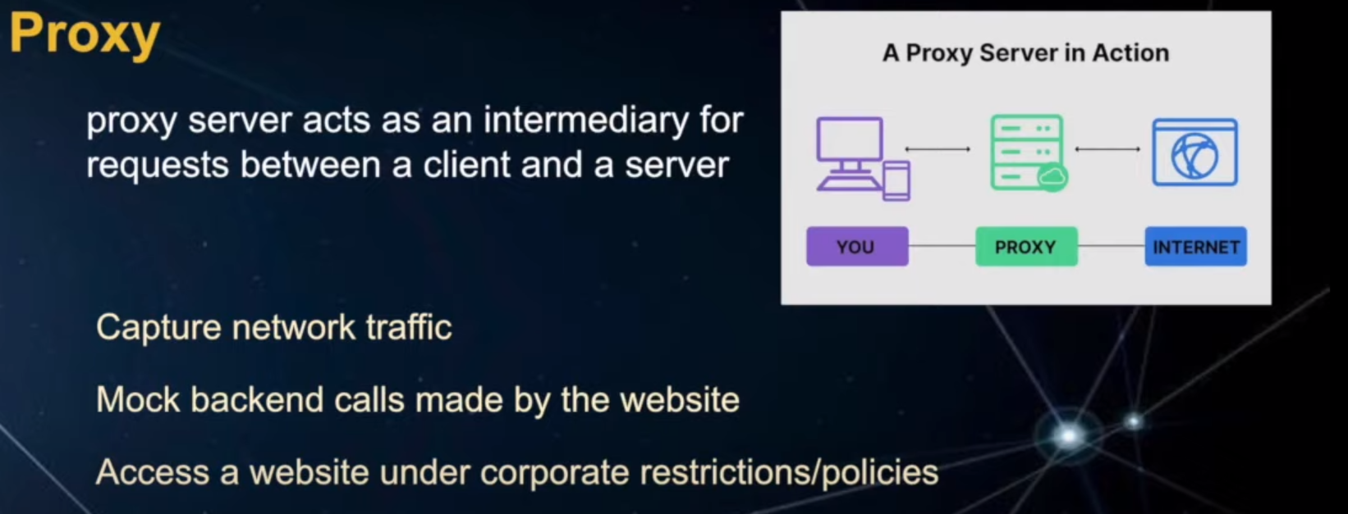

**Proxy? -->**

In layman's terms, think of a proxy as a middleman or a go-between for your internet connection.

Imagine you want to visit a website (let's call it Website A), but instead of connecting directly to Website A, you first connect to a proxy server (the middleman). The proxy server then connects to Website A on your behalf. It's like sending a friend to visit a place for you; your friend goes there and brings back information.

Now, why would you want to do this? Here are a couple of scenarios:

1. **Privacy**: Sometimes, you might not want Website A to know who you are or where you're connecting from. Using a proxy can help hide your identity because Website A sees the proxy server's information, not yours.
2. **Access Control**: In some cases, websites or networks restrict access based on your location or other factors. If you use a proxy server in a different location, it can help you access content that would otherwise be blocked.
3. **Monitoring**: Proxies can be used for monitoring and logging internet traffic. This can be helpful for businesses to keep track of what their employees are doing online.
4. **Security**: Proxies can filter out harmful content or malware before it reaches your device, providing an extra layer of security.

So, a proxy is like having a friend who goes to websites on your behalf, helping you stay private, access restricted content, or stay safe online.

**Summary:**

Learn how to use a proxy in Selenium for network traffic interception, testing, and bypassing restrictions. The tutorial covers setting up a proxy, configuring it with Selenium, and monitoring network traffic with Charles Proxy.

**Highlights:**

🌐 Proxy servers act as intermediaries between clients and servers.

🧪 Proxies are used for intercepting network traffic, mocking requests, testing, and bypassing corporate restrictions.

⚙️ Setting up a proxy in Selenium involves creating a Proxy object and configuring settings such as IP and port.

🌐 Charles Proxy can be used to monitor and debug network traffic.

🖥️ Use the ChromeOptions class for Selenium 4 to configure proxy capabilities.

🚀 Start Chrome with the configured proxy settings to capture traffic.

📊 Monitor network traffic in Charles Proxy for testing and debugging purposes.

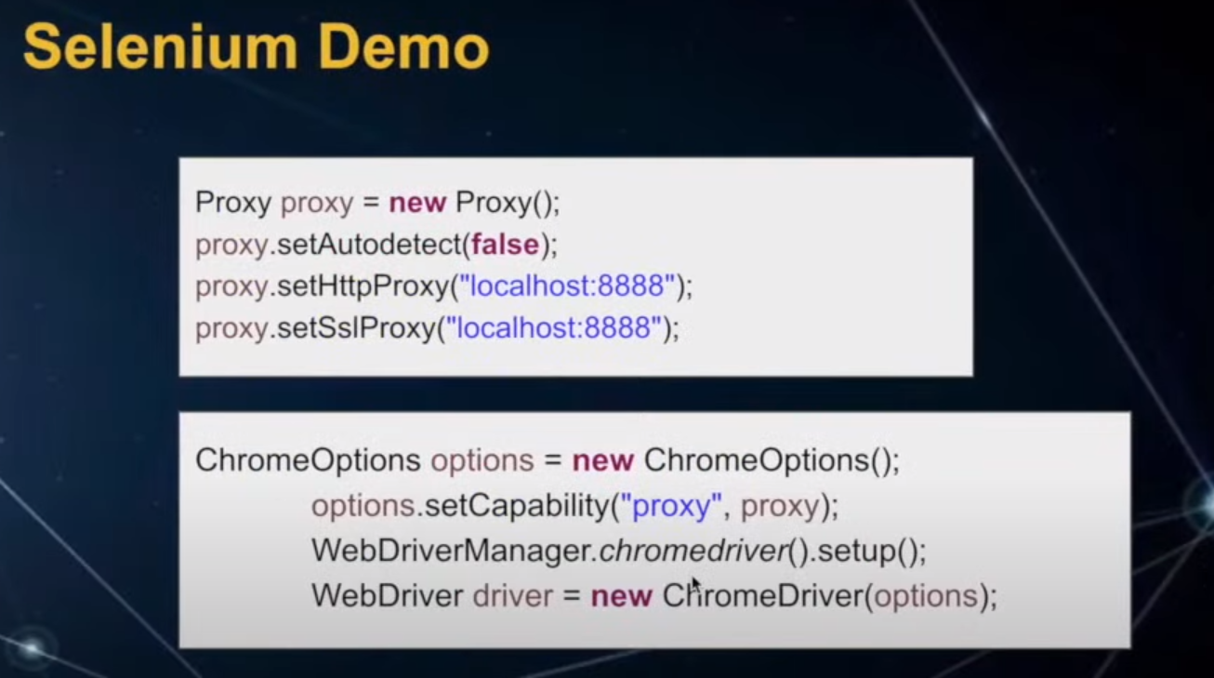

1. **Page Loading Strategy**

Learn about page loading strategies in Selenium 4, including : Normal, Eager, and None strategies, and how to implement them using Chrome Options.

**Highlights :**

🌐 Selenium offers three page loading strategies normal, eager, and none.

🚀 Normal strategy waits for complete page loading with all resources.

⏩ Eager strategy waits only for initial HTML document loading, faster but may lack resources.

⚡ None strategy waits for the initial page load, quickest but may not wait for rendering.

💻 Use Chrome Options to set the desired page loading strategy in Selenium 4.



Let's break down Selenium's three page loading strategies in simple terms:

**6.1. Normal Page Loading Strategy:**

* + Description: This strategy is like waiting for a webpage to load with all its bells and whistles. It patiently waits for everything on the webpage to load, including images, fancy styling (CSS), and dynamic features (JavaScript).
  + Imagine: It's like waiting for a cake to bake completely with all the icing and decorations before you can enjoy it. It ensures everything is ready before you proceed.

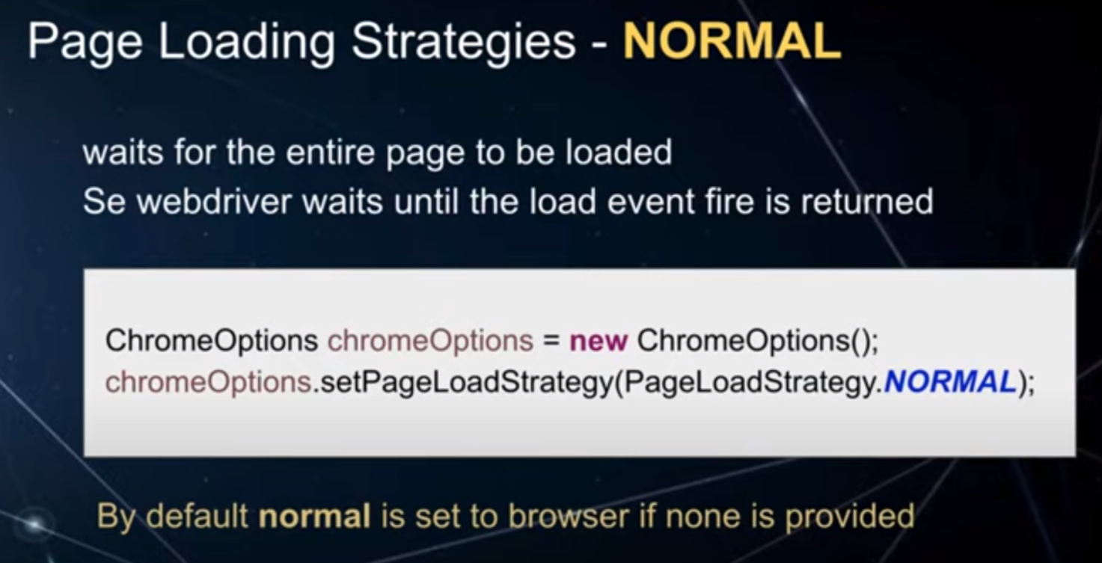

* 1. **Eager Page Loading Strategy:**
  + Description: This strategy is more impatient. It waits only for the main content of the webpage to load. It doesn't bother with the fancy decorations (CSS) or images. It's faster but might not give you the fully styled webpage.
  + Imagine: Imagine you're in a restaurant, and they serve your food as soon as it's ready on the plate. They don't wait for the fancy garnishes or sauces, so you get your food faster.

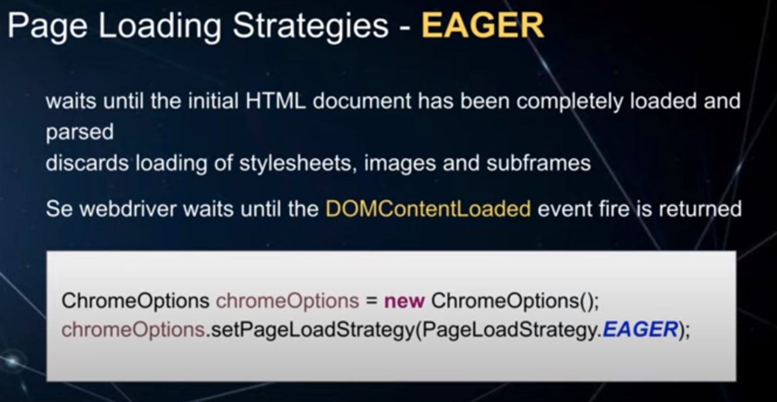

* 1. None Page Loading Strategy:

Description: This strategy is the quickest of them all. It doesn't wait for anything but the initial webpage to load. It doesn't care about images, styles, or anything extra. You might see a half-baked webpage.

Imagine: It's like walking into a room before it's fully set up for a party. You get to see the basics but not the full decoration or snacks.

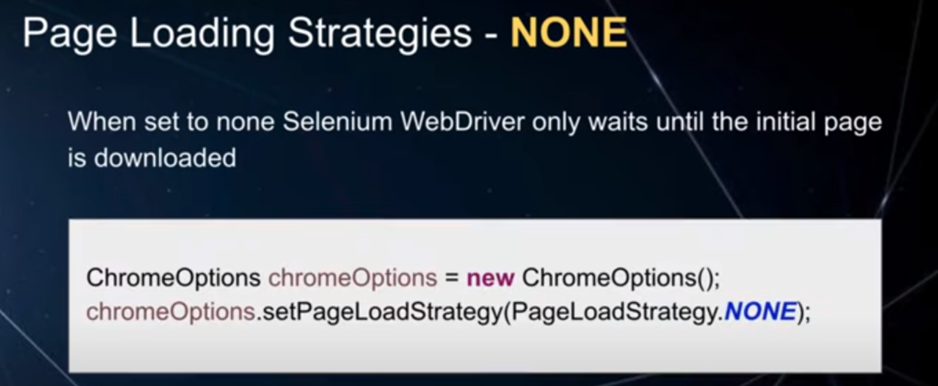

So, these strategies are like different levels of patience when waiting for a webpage to load in Selenium. You can choose the one that fits your needs, depending on how much you want to wait for the webpage to be fully ready.

1. **WebElements**

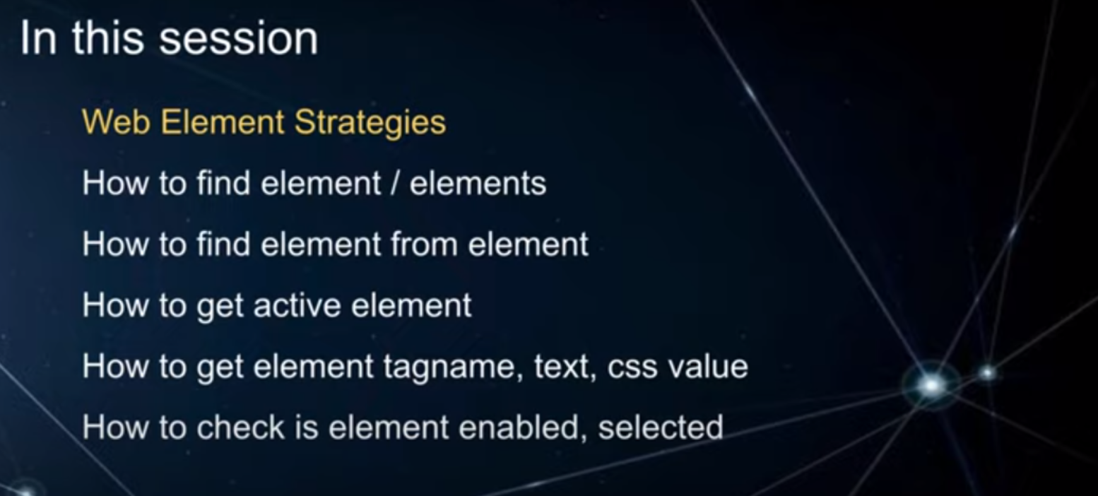

1. **Actions Class**
   1. **Keyboard Actions**

In layman's terms, Selenium WebDriver's Actions and Action classes are like virtual hands that allow you to interact with a web page in a more sophisticated and precise way.

Imagine you're using a computer and you want to do something on a website, like clicking a button, typing in a text box, or moving the mouse. Normally, you'd use your physical mouse and keyboard to do these tasks. But Actions and Action in Selenium WebDriver give you the ability to do these tasks programmatically.

Here's a breakdown:

1. **Actions**: Think of "Actions" as a set of instructions you can give to Selenium to perform a series of actions on a web page. These actions can be things like moving the mouse to a specific element, clicking, double-clicking, right-clicking, or even performing keyboard actions like typing text. It's like telling Selenium what you want to do, step by step.
2. **Action**: An "Action" is a single action or command that you want Selenium to perform within the set of Actions. It's like one specific task you want Selenium to do, such as clicking a button or typing text into a field. You can combine multiple Actions to create a sequence of actions to achieve a more complex task.

So, Actions help you script a series of Actions (tasks) that Selenium will execute on a web page, making it possible to automate interactions just like you would manually, but programmatically. It's like giving Selenium a virtual set of hands to perform tasks on a website.

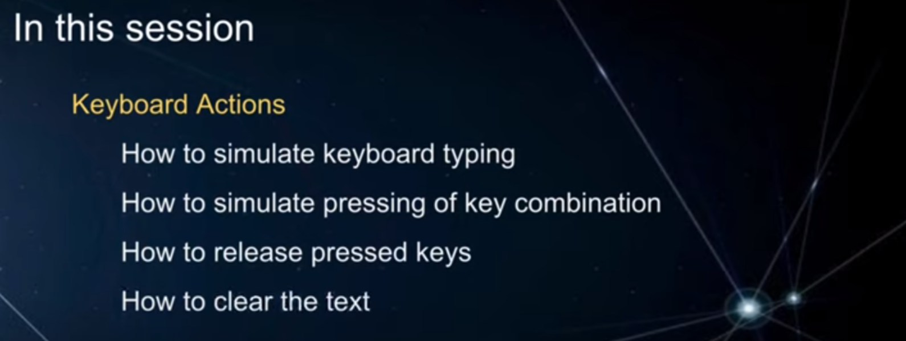

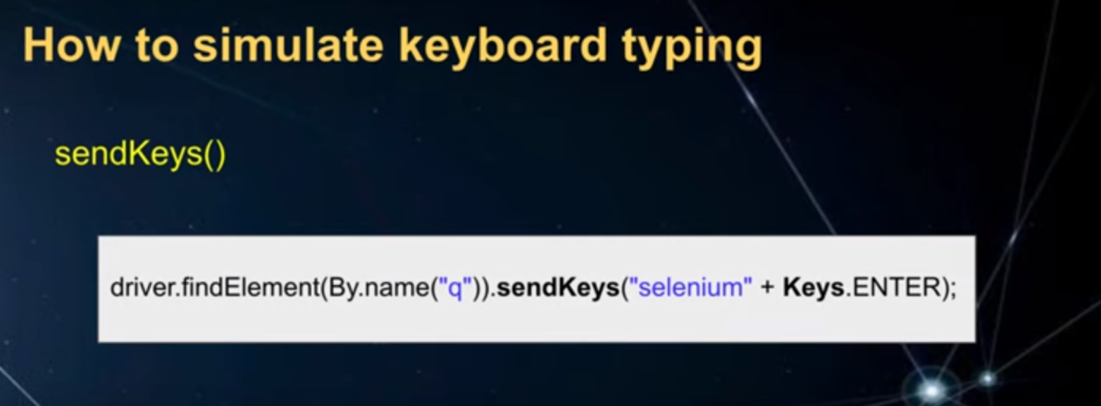

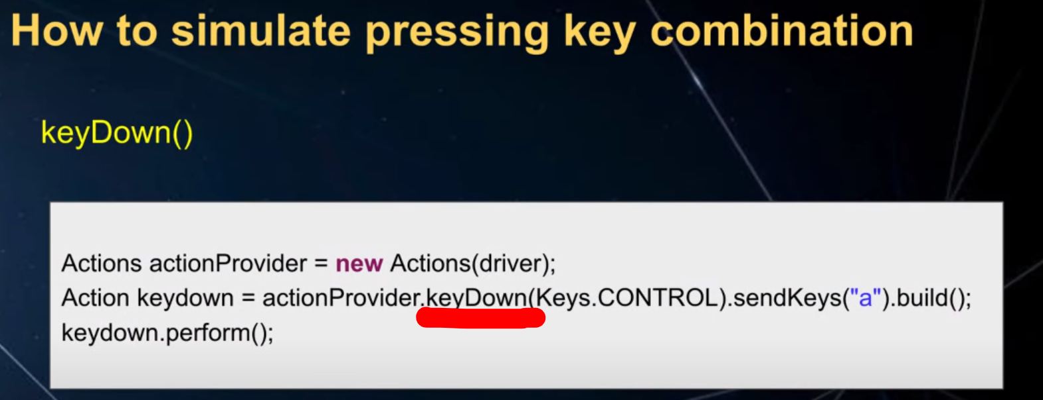

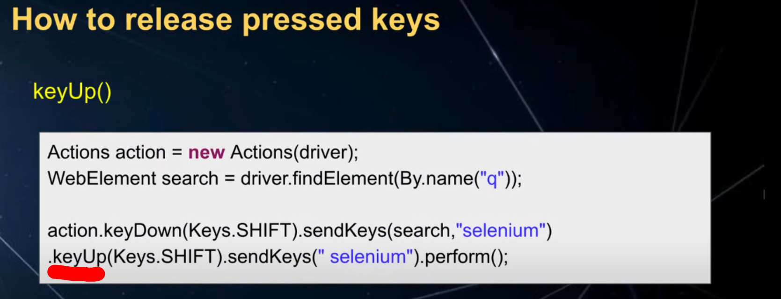

* 1. **Mouse Actions**

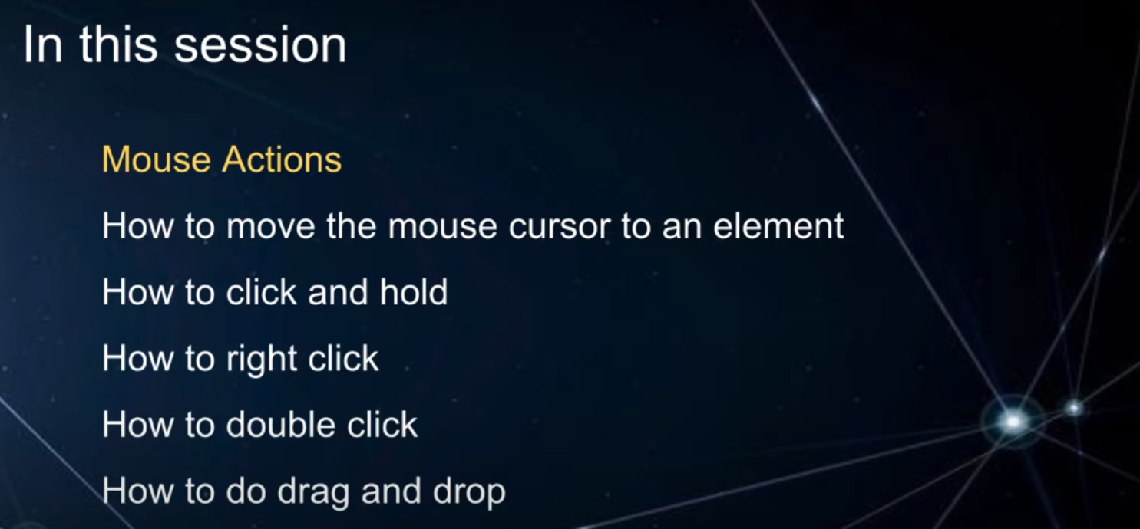

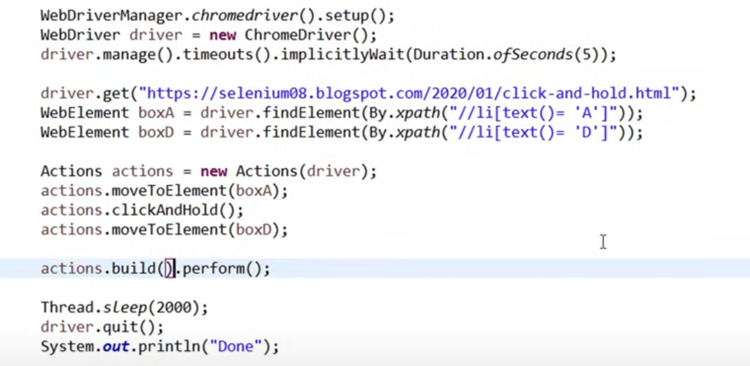

* + 1. **Mouse Actions : Context Click**

To right-click in Selenium, you can use the Actions class. This class has a method called contextClick, which takes an element as a parameter. This method will simulate a right-click on the given element.

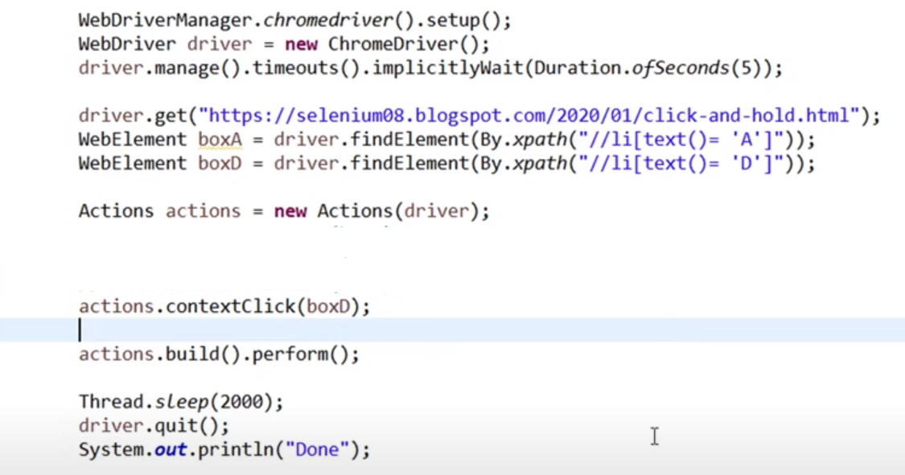

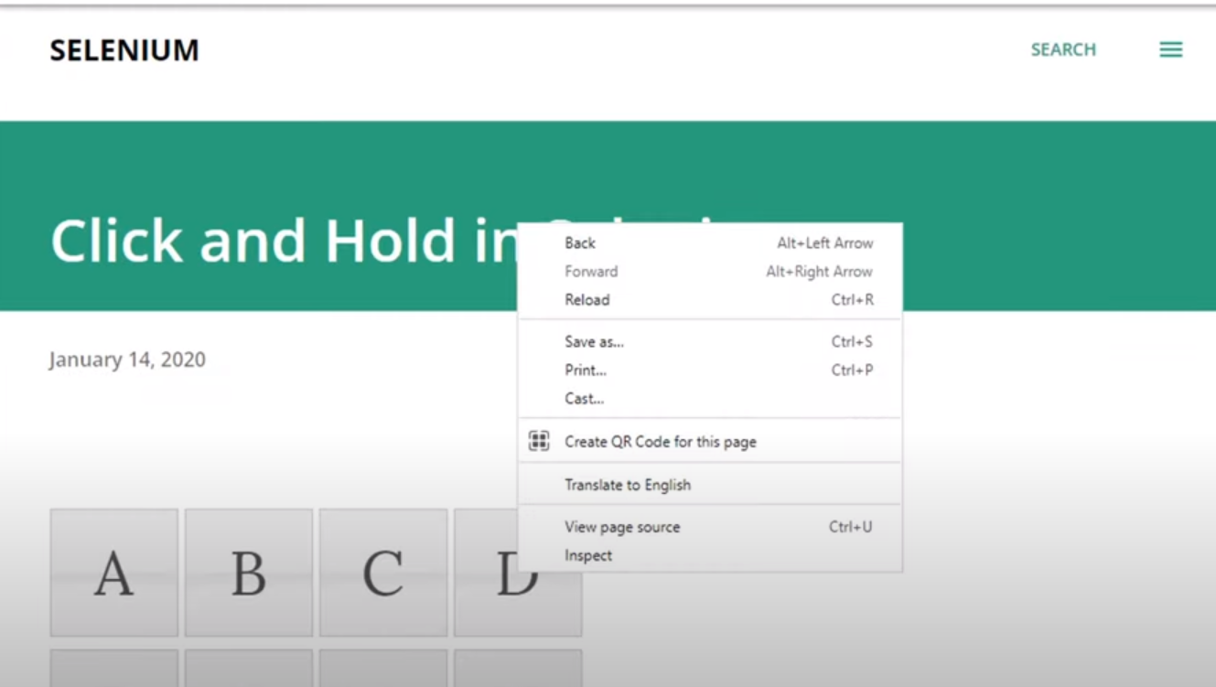

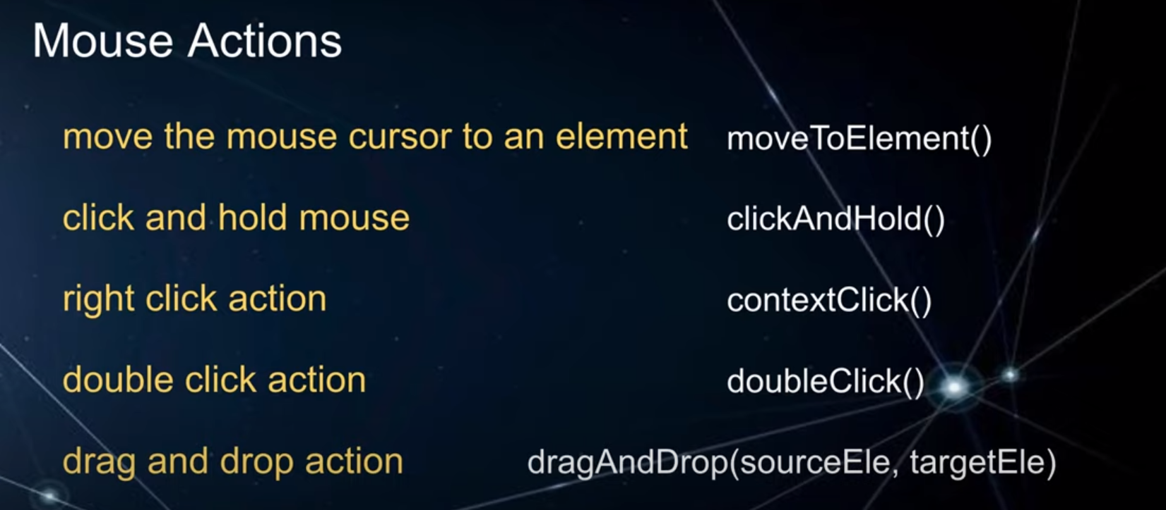

1. **DropDown using Select class**

